DRY CELL HHO 5”

[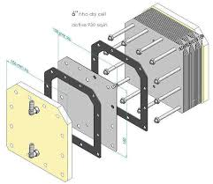](https://www.google.com/imgres?imgurl=https%3A%2F%2Fi.ebayimg.com%2Fimages%2Fi%2F302478922629-0-1%2Fs-l1000.jpg&imgrefurl=https%3A%2F%2Fwww.ebay.com%2Fitm%2F6-HHO-HYDROGEN-DRY-CELL-25Plates-12VDC-24VDC-48VDC-diy-engine-carbon-cleaning-%2F302478922629&docid=ECHaW6nWz_StWM&tbnid=W0CjuWZtbn_x6M%3A&vet=10ahUKEwjw26qd4MzcAhUH64MKHahZAcYQMwi5ASgPMA8..i&w=794&h=690&bih=783&biw=1440&q=dry%20cell%20hho&ved=0ahUKEwjw26qd4MzcAhUH64MKHahZAcYQMwi5ASgPMA8&iact=mrc&uact=8)

GASKET- 4” O RINGS <https://www.amazon.com/gp/product/B015O38M66/ref=oh_aui_detailpage_o02_s00?ie=UTF8&psc=1>

NUTS/BOLTS/STEEL/PLEXI- BOUGHT AT HOME DEPOT

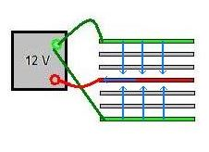

2 POSITIVE, 1 NEGATIVE, 8 NEUTRAL (4 ON EACH SIDE) => 12V/5=2.4V/water area (maybe high?)